Enquire with local Land Estates to get started on finding that perfect block!

Enquire

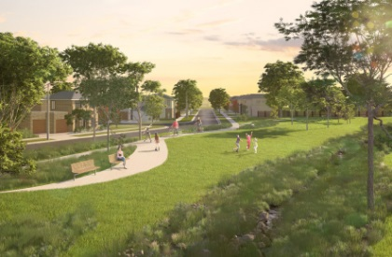

Users then click box to select estate

Welcome to Ascot an exciting and bright new opportunity for the re-development of the Pakenham racecourse land to establish a mix of residential, retail, recreation and community use assets located right here in the heart of Pakenham.



Welcome to Ascot an exciting and bright new opportunity for the re-development of the Pakenham racecourse land to establish a mix of residential, retail, recreation and community use assets located right here in the heart of Pakenham.



Welcome to Ascot an exciting and bright new opportunity for the re-development of the Pakenham racecourse land to establish a mix of residential, retail, recreation and community use assets located right here in the heart of Pakenham.



Welcome to Ascot an exciting and bright new opportunity for the re-development of the Pakenham racecourse land to establish a mix of residential, retail, recreation and community use assets located right here in the heart of Pakenham.

 